Correlation coefficient value | Correlation type | Meaning
1 | Perfect positive correlation | When one variable changes, the other variables change in the same direction.
0 | Zero correlation | There is no relationship between the variables.
-1 | Perfect negative correlation | When one variable changes, the other variables change in the opposite direction.
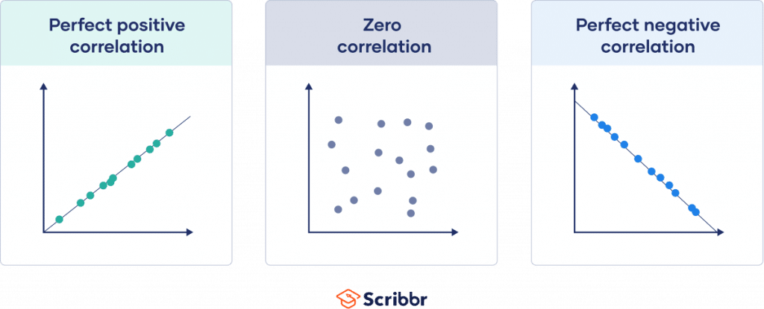
Correlation coefficient | Correlation strength | Correlation type
-.7 to -1 | Very strong | Negative
-.5 to -.7 | Strong | Negative
-.3 to -.5 | Moderate | Negative
0 to -.3 | Weak | Negative
0 | None | Zero
0 to .3 | Weak | Positive
.3 to .5 | Moderate | Positive
.5 to .7 | Strong | Positive
.7 to 1 | Very strong | Positive

Correlation coefficient | Type of relationship | Levels of measurement | Data distribution
Pearson’s r | Linear | Two quantitative (interval or ratio) variables | Normal distribution
Spearman’s rho | Non-linear | Two ordinal, interval or ratio variables | Any distribution
Point-biserial | Linear | One dichotomous (binary) variable and one quantitative (interval or ratio) variable | Normal distribution
Cramér’s V (Cramér’s φ) | Non-linear | Two nominal variables | Any distribution
Kendall’s tau | Non-linear | Two ordinal, interval or ratio variables | Any distribution

